Creating and applying Summative and Formative categories

Creating and applying the summative (or Formative) category

Creating the category
- On the module go to the Full Grade Centre
- Click Manage and select Categories
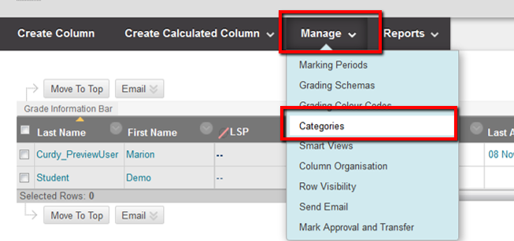
- Click the Create Category button and in the form that opens enter Summative Assessment and click submit.
NOTE – repeat this process for Formative Assessments
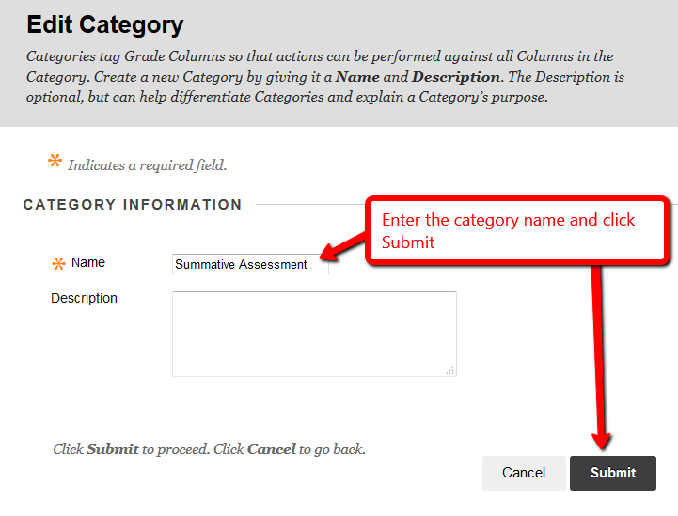

Applying the categories to the assessment columns in studentcentral
- Go to the full grade centre and for each summative assessment do the following…
- Click the column heading to open the column menu and select Edit Column Information
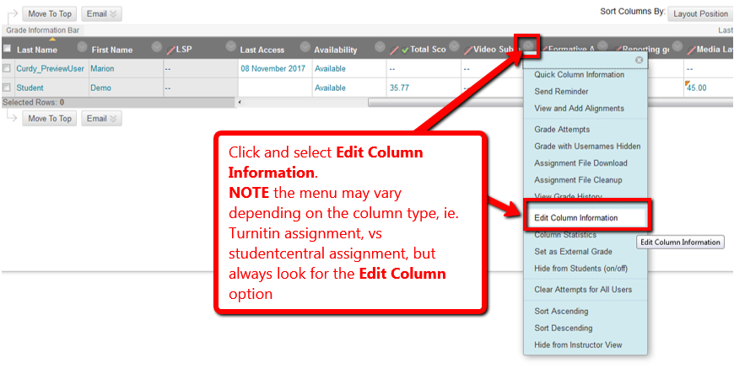
- Look for the Category field and click on the drop down and select the summative assessment category from the list available, then click Submit.
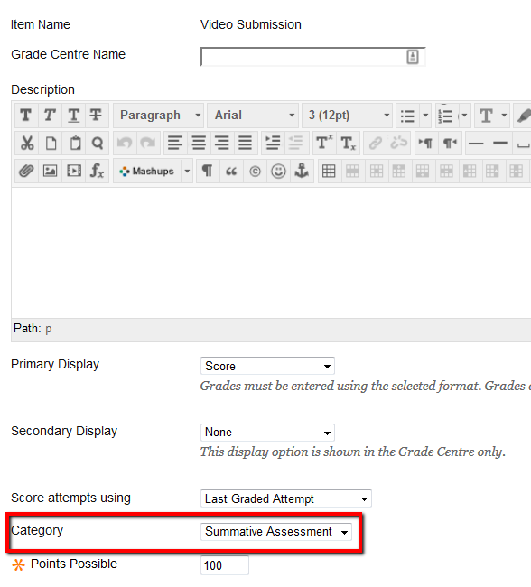
Now repeat for the formative assessment categories

