Setting up the Grade Centre for feedback in ARCH

Setting up a column for formative feedback
- Locate the correct module on studentcentral and go to the Control Panel>Grade Centre> Full Grade Centre
- In the screen that loads there are two required fields (marked with an orange *), Column Name and Points Possible, so enter a meaningful name in the Column Name Field (the students see this) and include the word Formative so that it’s easy to distinguish between formative and summative columns. In the Points Possible enter 1 (see screen shot below for details of what to complete).
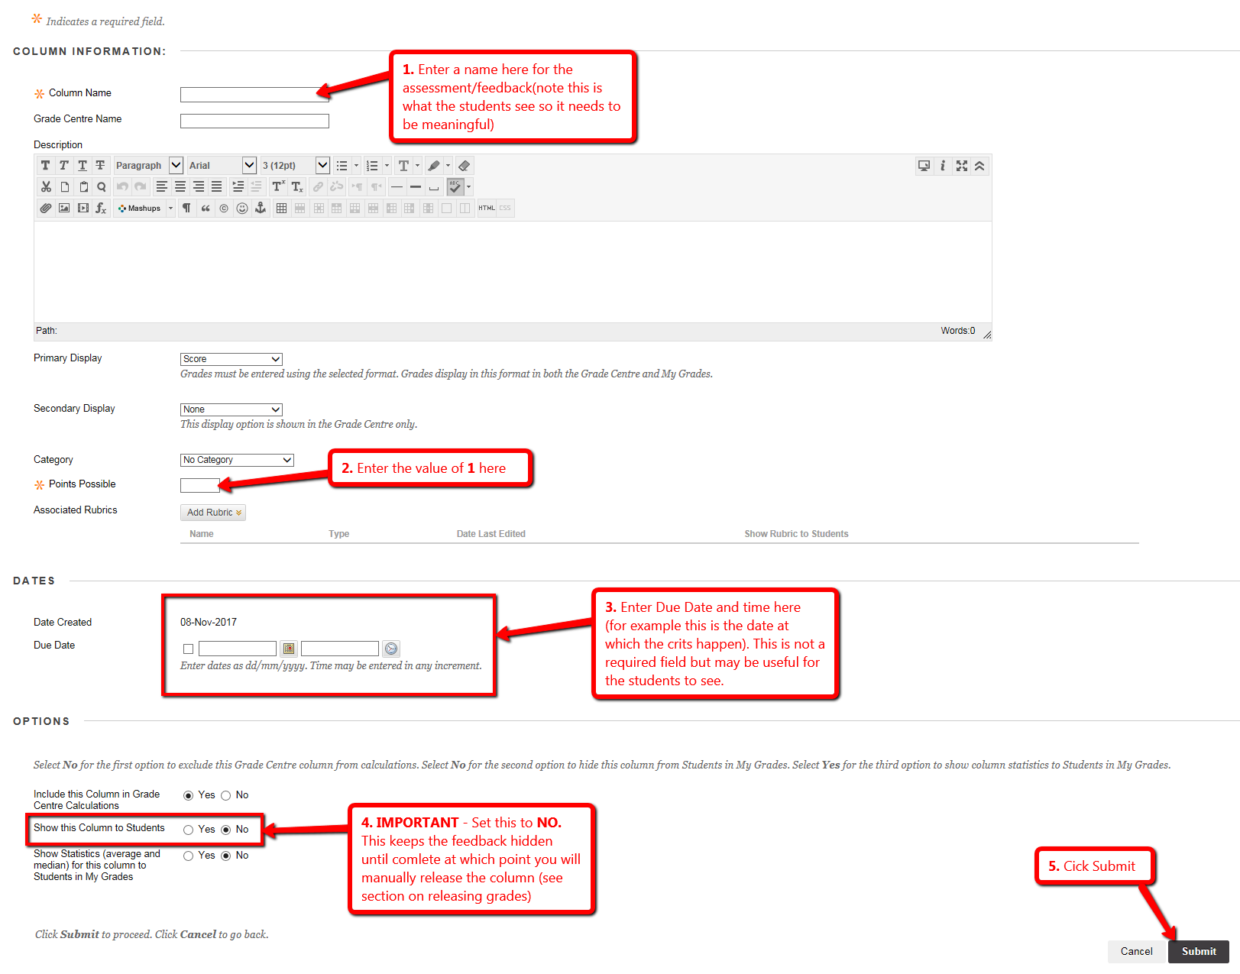

Setting up a column in the Grade Centre for Summative assessment
- Repeat step 1 above
- Enter the details as before, so column name etc. but this time in points possible enter 100 as that’s what the assessment will be marked out of.
