Setting

Setting up Studio Groups in studentcentral
- Open the relevant module on studentcentral and go to Users and Groups>Groups
- Now click Create and select Group Set Manual Enrol
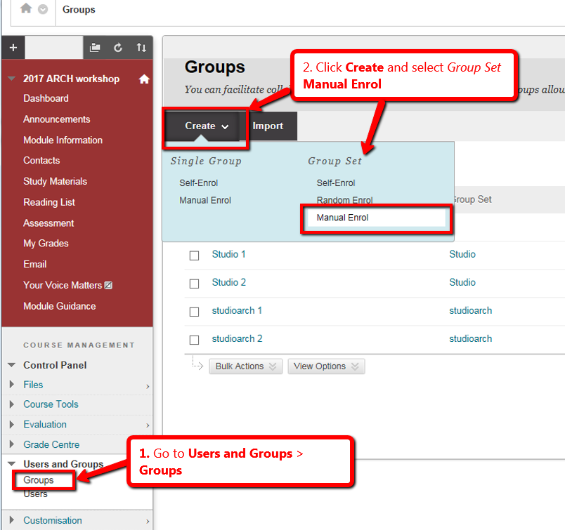
- Enter the details as in the diagram below
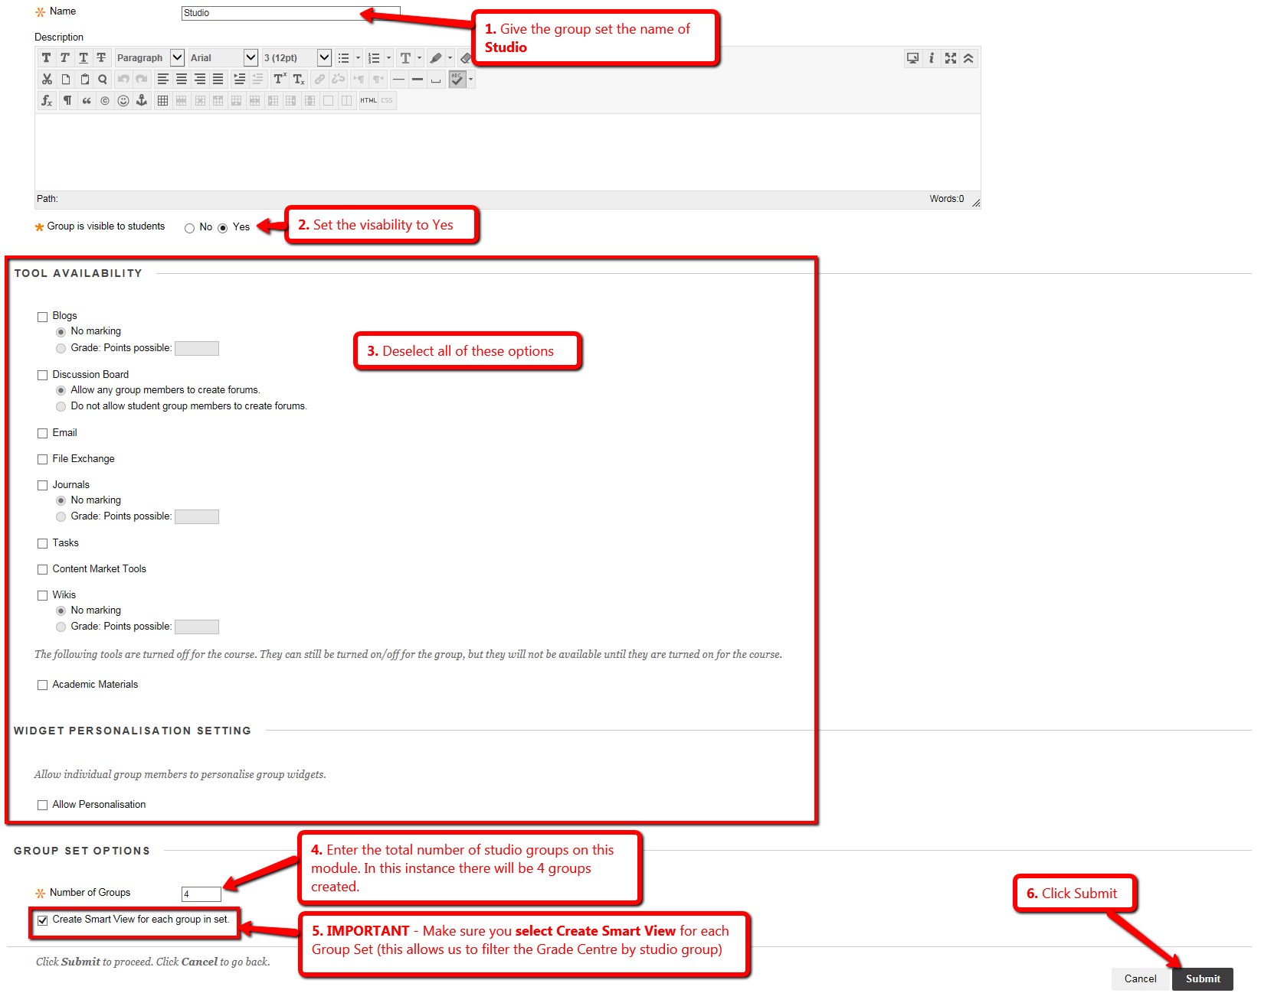
- Now you need to add the students to each of the studio groups you’ve created in the above process.
See details of what to do in the screen below.
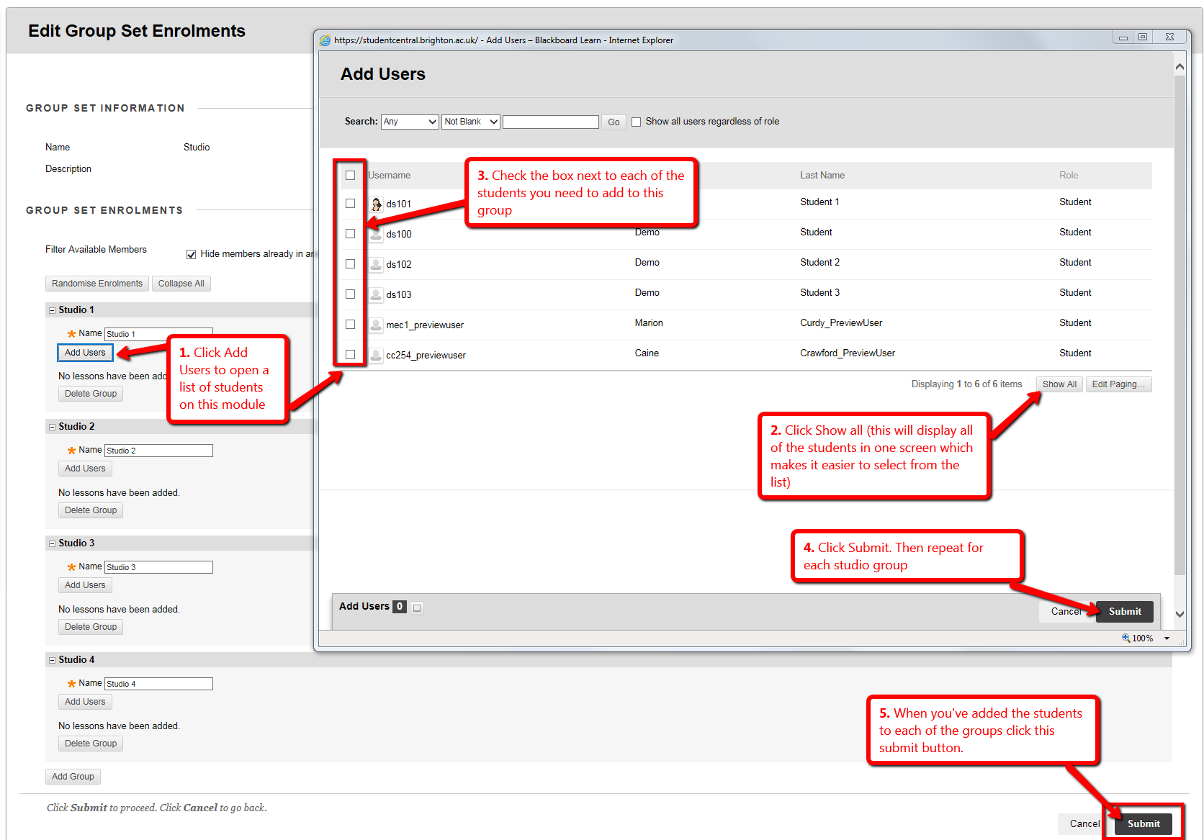

Adding the Groups to the Grade Centre Menu (Smart Views)
- Go to the Control Panel > Grade Centre > Full Grade Centre
- Click the Manage button and select Smart Views
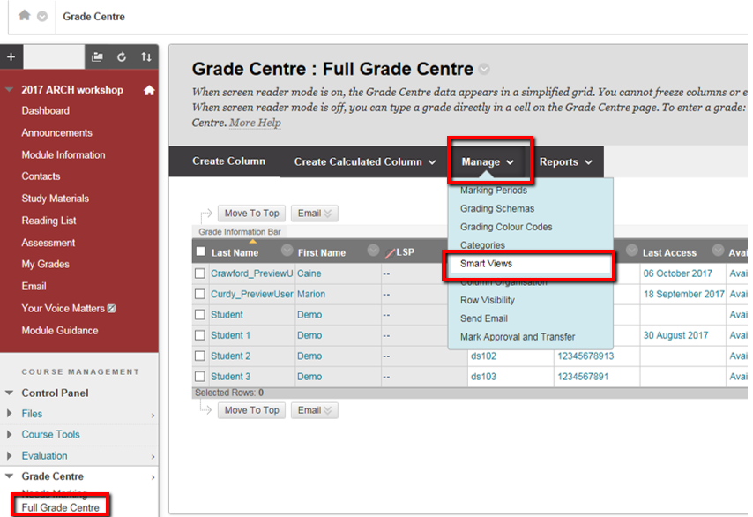
- Now you simply mark the studio groups as ‘favourites’
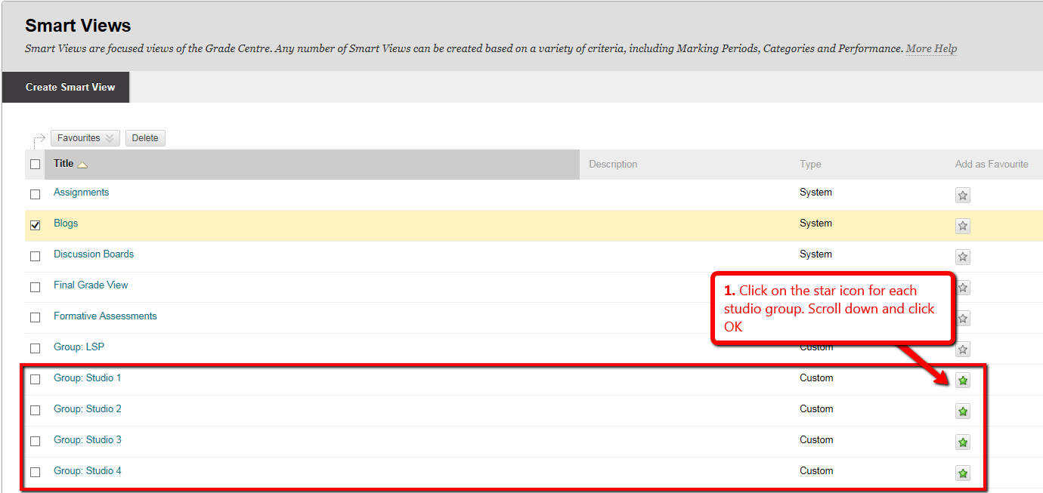
You’ll now see the groups appear under the Full Grade Centre.
