1. Under the Grade Center section of Course Management, click Full Grade Center
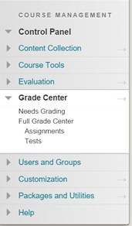
2. Click Create Column
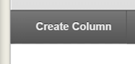
3. Give the column a name
a. If you would like the display text other than the Column Name, enter this text in the Grade Center Name textbox
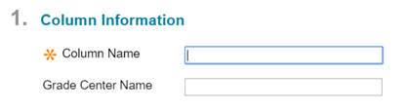
4. Enter a short description for the column
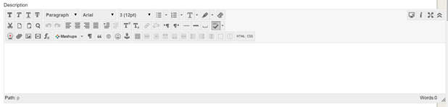
5. Select what kind of data you would like to display by changing the Primary Display
a. If you would like to display two separate types of data in one column use the Secondary Display section (ex. Both a score and
the corresponding letter grade)
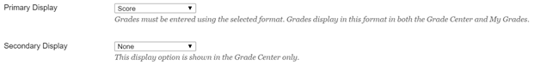
6. Enter the amount of points possible (100)
7. If needed, add a rubric by clicking Add Rubric
8. If you would like to set a due date, enter the date and time of day
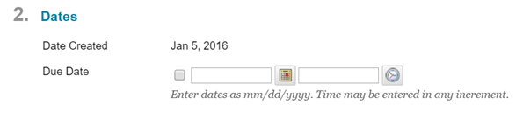
9. If you would like to include the column in calculations performed by Grade Center (ex, a column that totals the points of all grade
center columns) leave the Yes button checked. Otherwise, click No
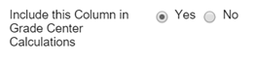
10. If you would like to show the column to students, leave the Yes button checked. Otherwise, click No
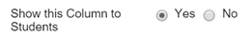

11. If you would like to show statistics about the column (such as the average class score) to the students, click Yes. Otherwise, leave the No button checked.
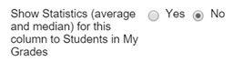
12. Click Submit

