Assessed Blog Post 1: Audit of a company
Asos
Shima Esfandiari 14816176

WE ARE AUTHENTIC, BRAVE AND CREATIVE TO OUR CORE
We focus on fashion as a force for good, inspiring young people to express their best selves and achieve amazing things. We believe fashion thrives on individuality and should be fun for everyone.

ASOS PLC is a global fashion destination for a range of things. The company sells and offers a range of fashion-related content on www.asos.com . The company's segments include UK, US, EU and RoW. It sells over 85,000 branded and own-label products through localized mobile and web experiences, delivering from its fulfillment centres in the United Kingdom, the United States, Europe and across the world (ASOS, 2018).

The two main ASOS competitors, according to Alexa, are Topshop and Boohoo; and all three companies are mostly focused on women’s online shopping pathway, rather than men’s; this includes all the different areas such as fashion, and beauty products, etc.(see Appendix 6) However, ASOS holds the highest rate of interest in clothing compared to the other two companies, as online shopping with ASOS is more attractive; the way the website is designed and detailed graphically gives a better visual experience to the buyer that includes models on the catwalk as short videos. (Alexa, 2018 and Asos, 2018)(see Appendix 4&10)

According to the Alexa website, ASOS obtained search engine optimization by paying to ensure keywords would lead to their site staying ahead of competitors. The result of which means searches for ASOS cannot be compared with those of the other two competitors, as the difference is enormous (Alexa, 2018)(see Appendix 5)

Customer journey experience with ASOS is professional and easy to follow right up until items are received. Moreover, returning items is free and easy, as all the collection point centres as well as post offices can be used to return items. The company usually sends an email out to get feedback on the customer buying journey experience in order to improve their services. Secure payments through Paypal or other known companies could strengthen customers’ interest and trust in buying from their website (Chaffey & Ellis Chadwick, 2016 p. 24).(see Appendix 3)

Regarding target audiences, and comparing Google, Yahoo, Instagram, Facebook, and blogging; Instagram and bloggers have the highest rating, as the age range most interested in ASOS products is the younger generation, and these are extreme Instagram users. ASOS have a high rate of advertising through social media with bloggers and the ASOS Instagram page itself has got an online route for shopping.(see Appendix 7&2) ASOS use micro influencers (500-10,000 followers), to share their latest fashion finds on platforms like Instagram. The use of micro-influencers is something that makes the brand feel more approachable and authentic to young customers. (Davis, 2018) Also, offering a student discount for NUS cardholders provides an excellent opportunity to acquire more customers than the other two companies, as the student age range covers a good part of the online shopping demographic. Two customers journey map have been created based on the buyer personas displayed in appendix 1. (Alexa, 2018; ASOS,2018 and Chaffey & Ellis Chadwick, 2016 p. 24).(see Appendix 1&2&3)

Digital media channels use online communication techniques such as search engine marketing and online E-PR to enable maximization of favorable mentions of a company/brand on third-party media sites (Chaffey & Ellis-Chadwick, 2016). According to Alexa data ranking, ASOS holds the highest rank for rate of traffic; and visitors are mainly searching directly for the ASOS website as it is a well- known for online shopping. Moreover, the number of repetitions for the ASOS website itself is much higher than for its competitors (Mathis, 2018 and Alexa, 2018).(se Appendix 8)

In conclusion, I would say that all the evidence shows that ASOS compares favorably with its two competitors; as the customers’ journeys to buy and return products demonstrate. Furthermore, the overall shopping experience with ASOS from the range of products available up to the sales experience has made this online shop successful and popular.(see Appendix 9)

Bibliography
Anon (2018) ASOS [online] Available at: https://www.asos.com/about/[Accessed 25 November, 2018]

Alexa team (2018) alexa [online] Available at: https://www.alexa.com/comparison#?sites=asos.com&sites=boohoo.com&sites=topshop.com [Accessed 1 December 2018]

Agius, A (2018) hubspot[online].Available at:https://blog.hubspot.com/service/customer-journey-map[Accessed 29 November, 2018]

Anon,(2018) hubspot[online]. Available at:
https://www.hubspot.com/make-my-persona[Accessed 1 December 2018]

Bodine, K (2018) blog (online) Available at: http://kerrybodine.com/blog/[Accessed 29 November 2018]

Chaffey, D and Ellis-Chadwick, F(2016)Digital marketing.6thed.Harlow[etc.]:Pearson.

Davies, A(2018)blog(online)Available at :
https://blog.ometria.com/why-we-cant-get-enough-of-asos-insiders [Accessed 5 December 2018]

Mathis, W (2018) Bloombers. [online] Available at: <www.bloomberg.com/news/articles/2018-10-17/asos-profit-jumps-as-online-retailer-beats-the-summer-heat[Accessed 1 December 2018]

Saumya, V (2016) Artifacia blog [online] Available at: http://blog.artifacia.com/12-buyer-personas-for-online-retail-shoppers/#FashionableDiva [Accessed 29 November, 2018]

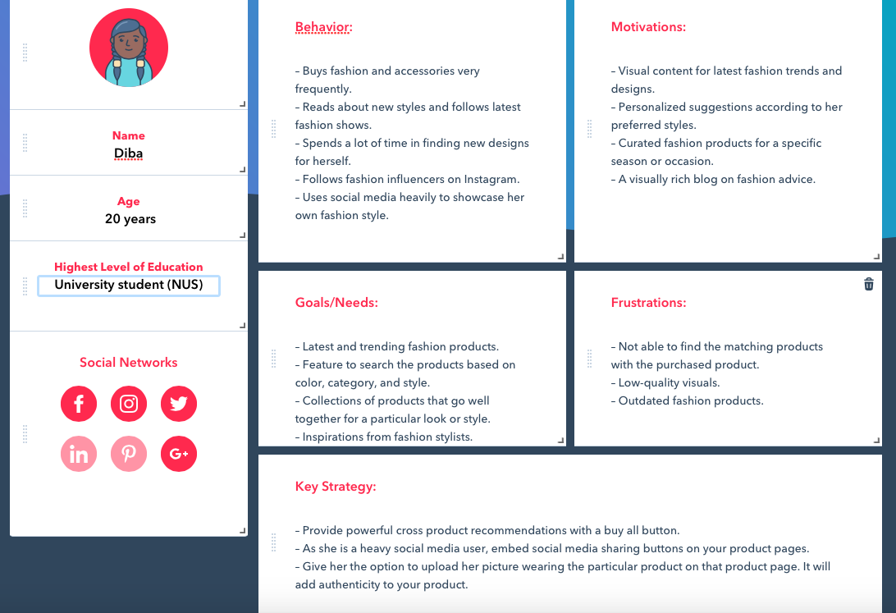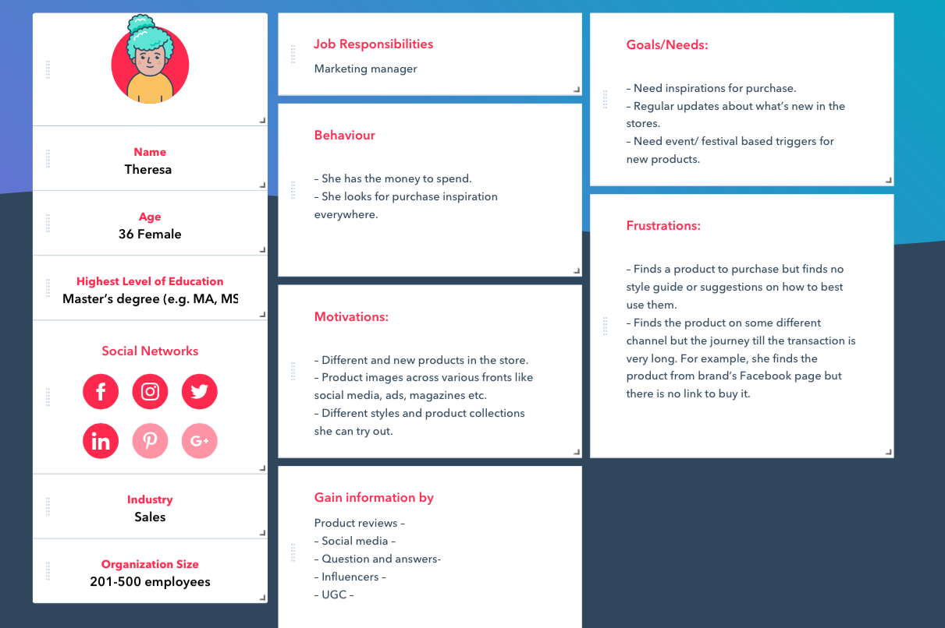
Agius, A(2018)( Appendix 1)

Appendices:
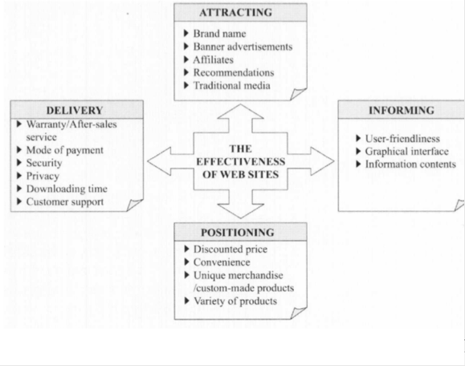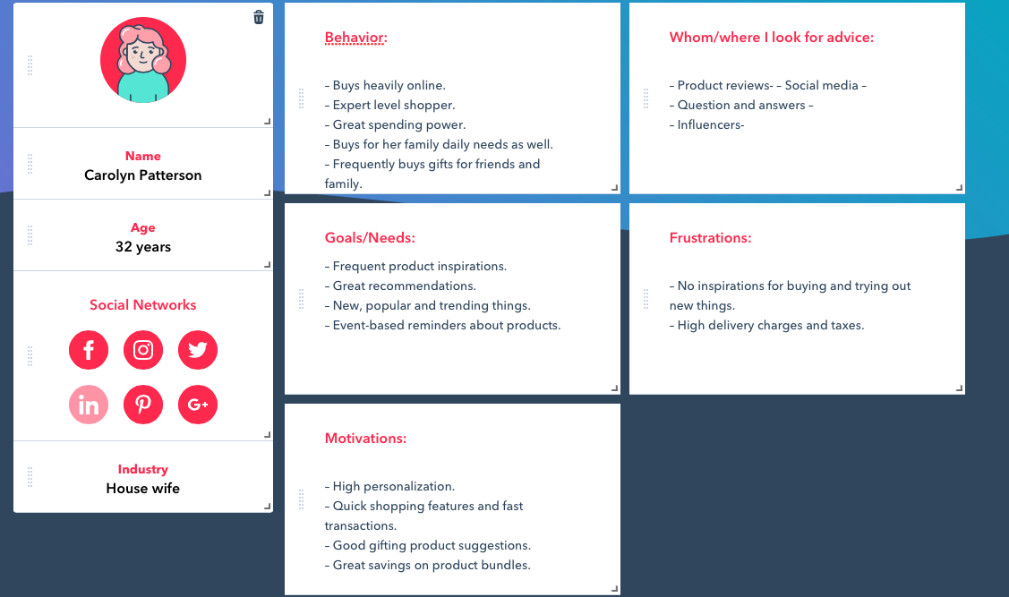
Agius, A (2018)(Appendix 1)
(Appendix 2) Chaffey & Ellis Chadwick (2016) Pg 24

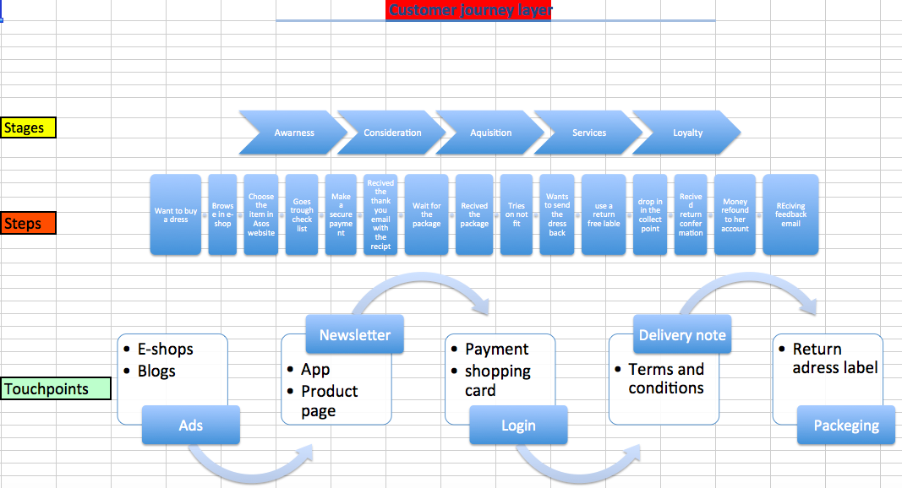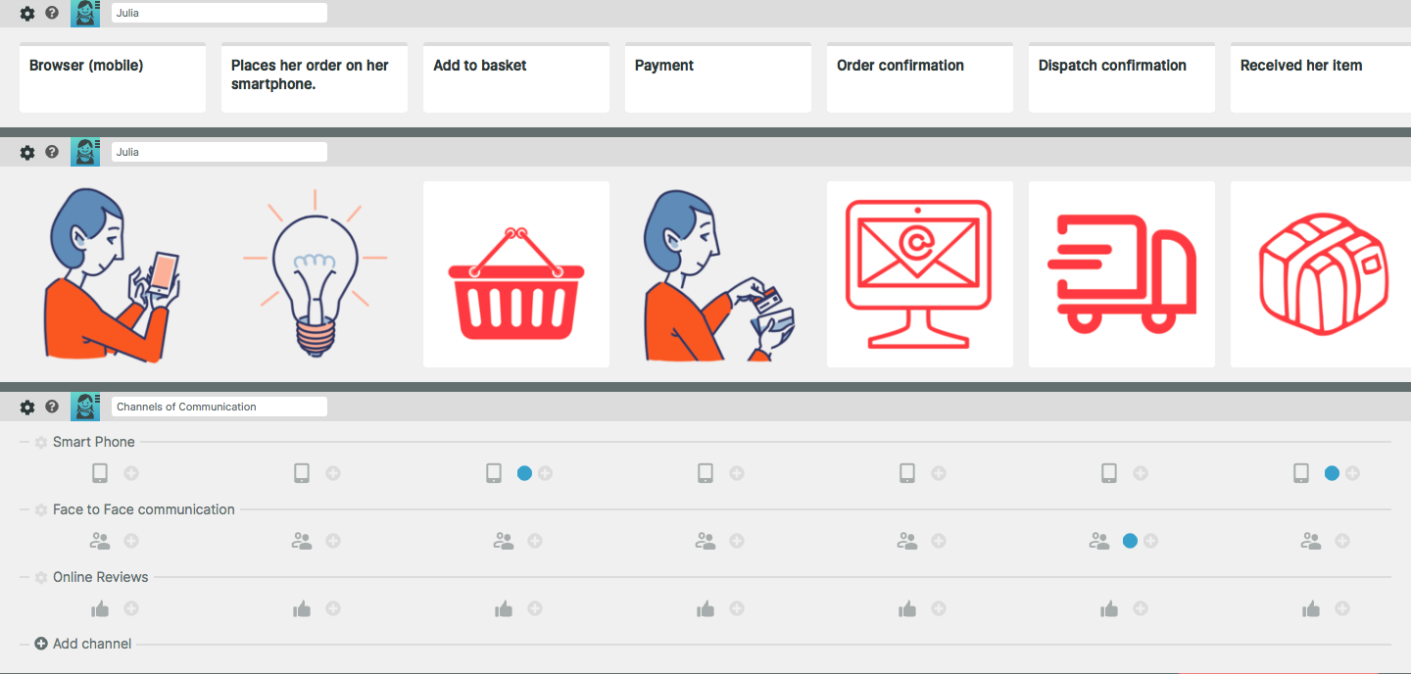
Agius, A(2018)( Appendix 3)

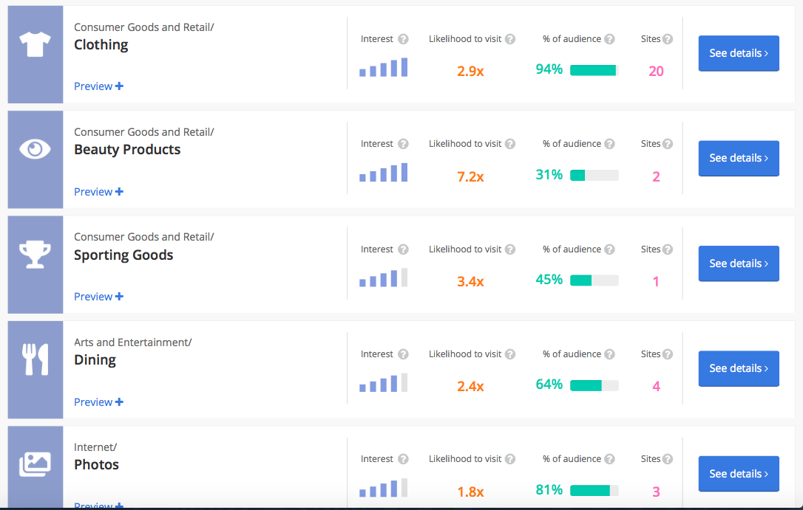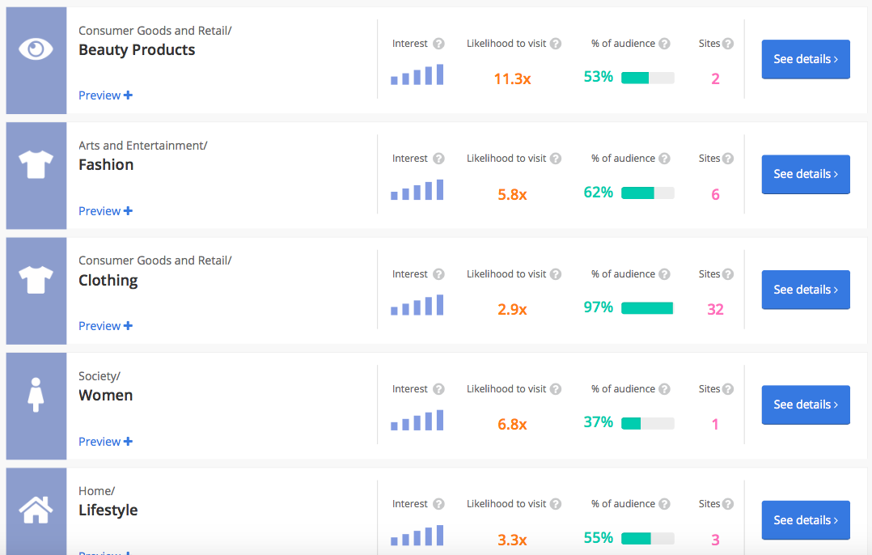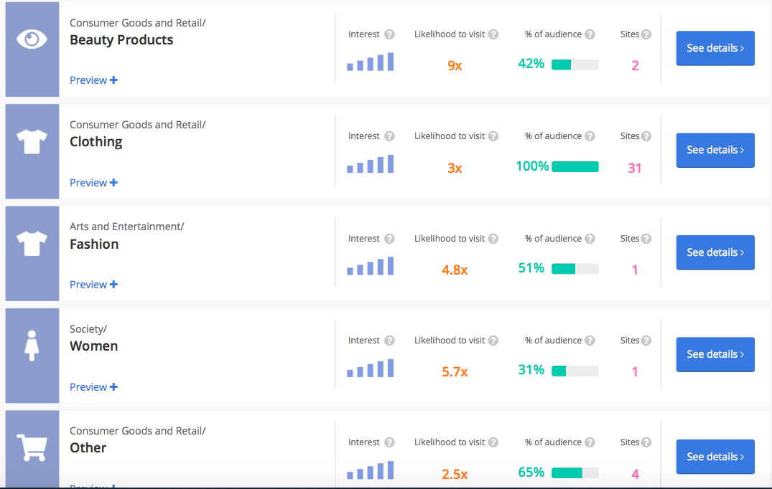
(Appendix 4)
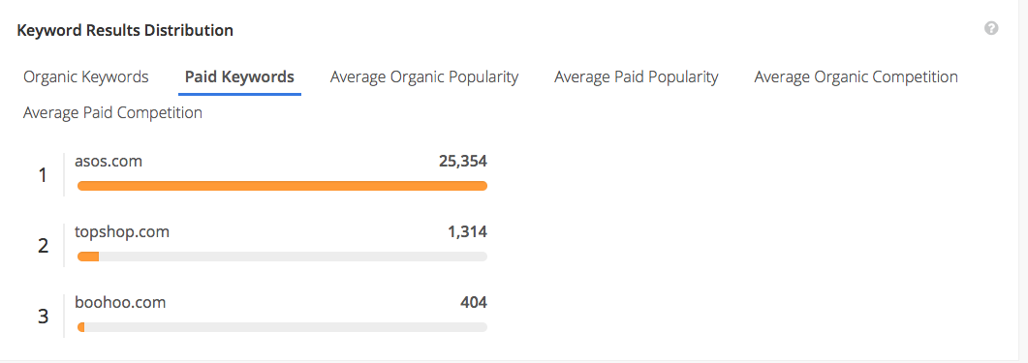
(Appendix 5)
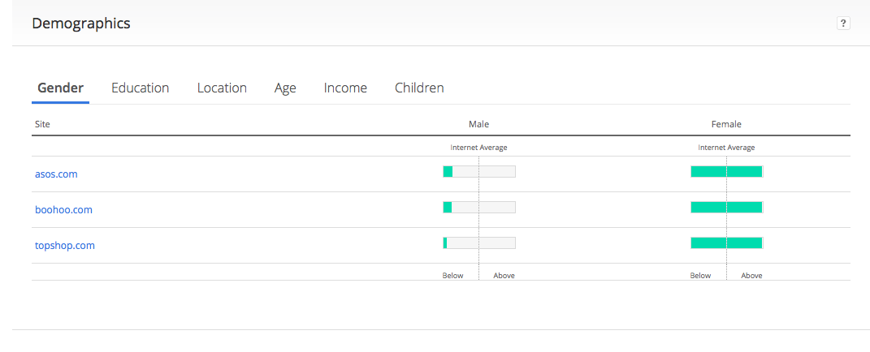
(Alexa,2018)( Appendix 6)

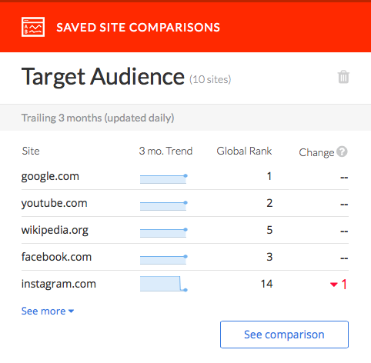
(Appendix 7)
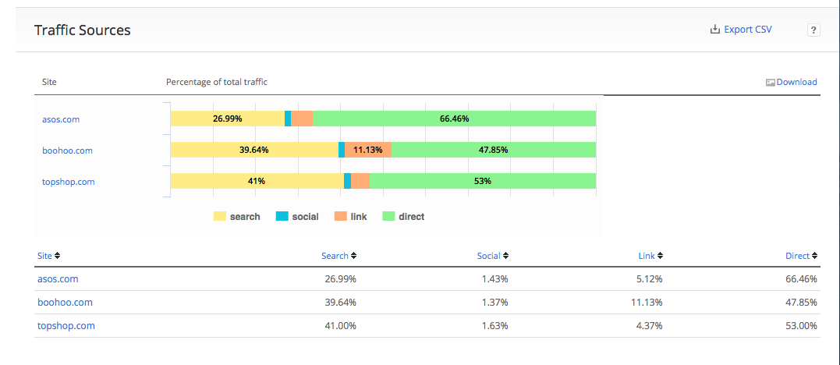
(Alexa, 2018)( Appendix 8)

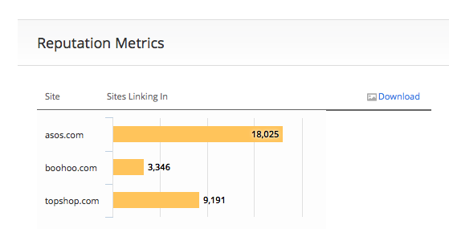

(Alexa, 2018)( Appendix 9)

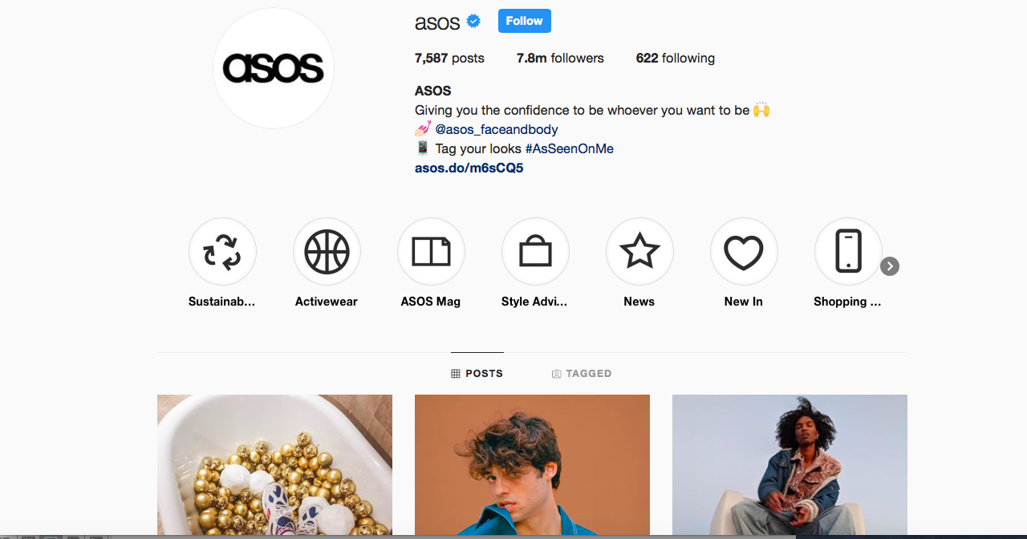
https://www.instagram.com/asos/?utm_source=ig_profile_share&igshid=14qz1o39y5l2u

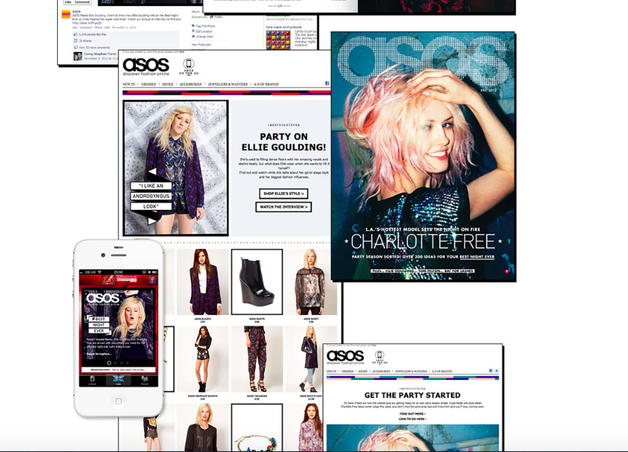
(Appendix 10)

